Task 1: Real-Life Uses of a Multimeter

- Checking a laptop charger — the multimeter shows if the charger is actually giving out the right voltage or if it's dead.
- Checking a PC power supply when the computer won't turn on — the multimeter tells you if the power supply is sending power at all.
- Checking a phone battery that won't charge — the multimeter shows if the battery itself is dead, or if the problem is the cable/charger instead.

Task 2: POST Card Video Summary

A POST (Power-On Self-Test) card is a hardware diagnostic tool used to identify problems during computer startup. It displays POST/diagnostic codes generated by the motherboard BIOS/UEFI. Each code represents a particular stage of the boot process or can indicate a hardware problem such as RAM, CPU, or graphics initialization. In the demonstration, the POST card helps identify the stage at which the motherboard fails, allowing the technician to focus on the suspected hardware component.

Example: If the POST process stops at a memory-related code, the technician can check or reseat the RAM modules.

Task 3: Software Diagnostic Tool

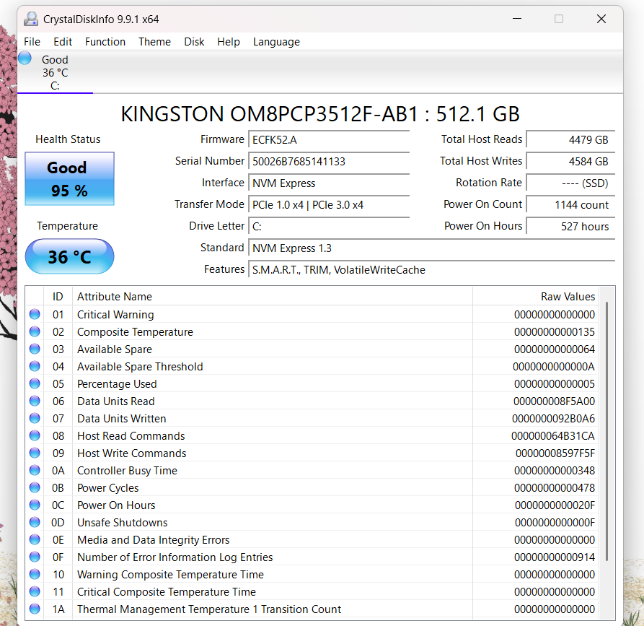

Task 4: Comparison of Troubleshooting Tools

Tool | What it checks | Example Problem Detected
Multimeter | Voltage and continuity in cables/components. | A charger not outputting 5V (dead charger)
POST Card | Boot-stage checkpoints via hex codes | RAM or CPU not initializing properly during boot
Software Diagnostics | Hardware health, temperature, voltage and storage status | Overheating CPU or failing HDD/SSD

